Hw9 公衛二 梁嫚芳 b07801003

1. **Complete the KM tables and plot the KM curves for Sj(t) = P(T > t|X*= j), j = 0; 1.**

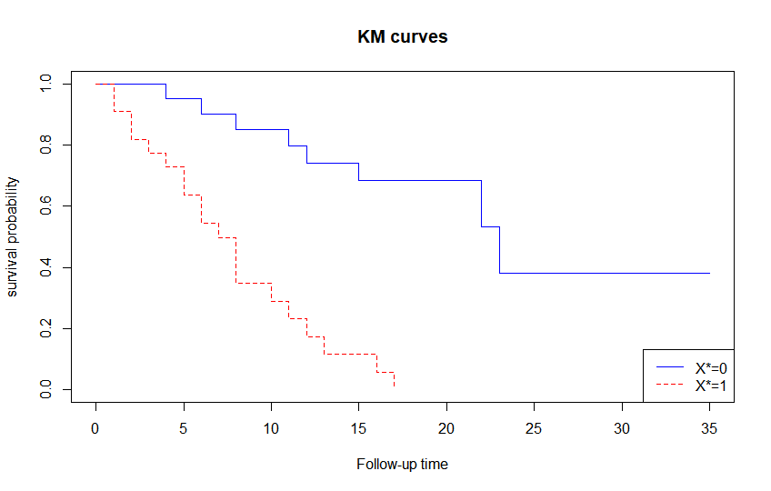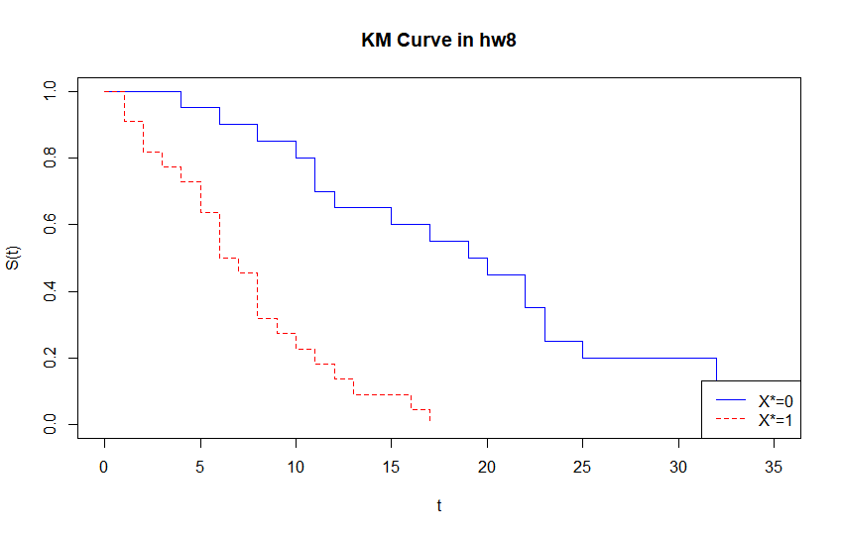

1. **Based on your KM curves, is there any difference between the remission time behaviors of two groups? Write down your observations.**

根據上左圖，X*=0的KM curve較X*=1的曲線下面積大，即WBC<median(WBC)比WBC≧median(WBC)的面積更大，且X*=1(WBC≧median(WBC))在t=16~17之間曲線值到達0，因此WBC會影響remission time。

1. **Comparing your results with the survival function using Z only (HW8). Will survival analysis provide different conclusion? Write down your observations.**

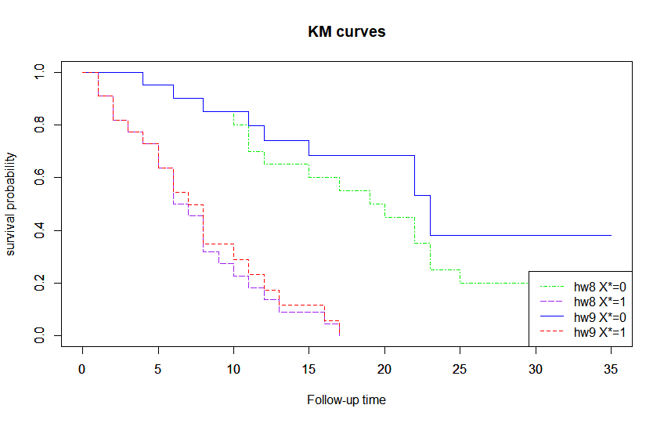

觀察將hw8與hw9疊圖結果，hw9的curve，無論是X*=0或X*=1皆不比hw8低，代表忽略censored的hw8相較於hw9低估了survival probability，survival analysis will provide different conclusion in contrast to the results with the survival function using Z only。